--IN School committee--

October 5, 2021

ORDERED:

That Superintendent Recommendation #21-292, Approval of Private School – Malik Academy return to original location at 808 Memorial Drive, Cambridge, Massachusetts, be adopted as follows: that the School Committee approve Malik Academy return to its original location at 808 Memorial Drive, as a private school, in accordance with the requirements of M.G.L. Chapter 76, Section 1.

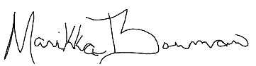
A true copy:
Attest:

Manikka Bowman
Vice-Chair of the Cambridge School Committee

c: Superintendent

